Strategies for data analysis
Have a dataset you’ve always wanted to explore? Lots of numbers you need to make sense of? In seconds, generative AI can help you spot patterns, notice connections between data points, and identify trends, all of which can empower you to make data-backed decisions with confidence.
All it takes is the right prompt. Writing a prompt to analyze a dataset can come with some quirks. But one thing to keep in mind throughout this reading is that the trusty prompting framework will guide you. That means you’ll Thoughtfully Create Really Excellent Inputs, only this time, you’ll tweak your strategies slightly to make them more dataset-friendly. Here are a few prompting strategies to help you get the most out of your data. And remember—always review your company’s policies before including sensitive or confidential data in your prompts.
Shape your prompt to the model’s abilities
When it comes to using gen AI tools to analyze your data, your prompts need to account for the strengths and limitations of the technology you are using. Understanding what sort of data analysis a gen AI tool is good at will help you tailor your prompts and get the most from your outputs.
Here are a few examples:
- Text analysis: Easily surface themes, determine tone, and classify key topics in text-based data. Have a few thousand open-ended responses from a community survey? Gen AI can help you quickly understand what’s most important to people, how they feel about the town’s proposed plans, and where the final initiative should make an impact.
- Data augmentation: Expand a limited dataset with simulated data to make it more robust. Say you work in fraud prevention. You want to analyze your company’s data about fraudulent purchases, but there are only a handful of data points. You can prompt a gen AI tool to generate new data from your current dataset to get a more comprehensive view of how fraud might happen and what to look out for. The key with data augmentation is to be transparent about what's real and what's augmented data, and the augmentation should be as realistic as possible. Augmentation can’t give you hard facts, only suggest trends. Like with the other data uses, you should always check your organization's policies.
- Question and answering: Get answers about your data in plain language, like whether your sales from last quarter were up or down. It’s like checking in with your colleague who compiled the information—just with fewer emails.
- Scenario analysis: By noticing patterns in past data, gen AI tools can make educated guesses about what might happen in the future. That means you can play out different scenarios to check what kind of impact they might have, like prompting to ask how a change in traffic patterns would impact your commuting time, or which days of the week your office space should expect the highest number of visitors.
- Image and visual analysis: Gen AI can help you quickly identify patterns and come to conclusions about your visual data without having to sift through stacks of images or watch hours of footage. You could even paste in a chart displaying your team’s sales figures for the past two years in your prompt, and ask questions about it for more focused analysis.
- Customer and market research: A gen AI tool can analyze surveys, social media, and other industry-specific data like charts and graphs to uncover what customers want and how your market is changing.
If you’re eager to use gen AI tools, but need to complete a data analysis task they’re not really built for—like rigorous statistical analysis, or really anything with highly structured data—don’t worry. You’ll just need to adapt how you prompt the tech to best suit its capabilities. For example, instead of having the gen AI tool do statistical analysis for you, ask it to suggest the most effective methods based on your data with step-by-step instructions. Even if you’re not a coding expert, you can use gen AI to help you learn about different analysis methods quicker than if you were learning on your own. Designing your data analysis prompts to align with the limitations of gen AI doesn’t have to restrict your work. Keeping the tech adaptable to and useful for your needs can open doors to unexpected creativity.
P.S. Since we’re discussing the limitations of AI, now’s a good time to remind you about hallucinations. If you’re following our prompting framework, you’ll be evaluating outputs as you go. But keep in mind that spot checking doesn’t really work for datasets—out of 100 generated data points, only 10 might be hallucinations. So keep a close watch on your outputs, and try to only generate information that can be easily cross-referenced.
Get your dataset ready
An output is only ever as good as the data it’s based on. That means you need to validate your data and continually check the information you’re analyzing with gen AI.
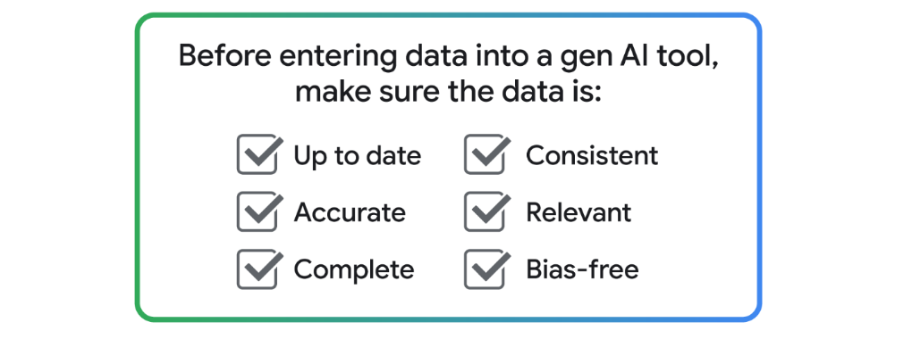
Luckily, gen AI tools can help you get your dataset prepared and ready. Try using a gen AI tool to identify errors, spot strange-looking data points, and standardize how things are formatted.
For example, maybe you want to figure out if your dataset is inaccurate. Here’s a prompt for that:
Here's a sample of my data. Identify any potential issues or inconsistencies in the data, and suggest ways that I can address them.
Cleaning up your data before conducting further data analysis is also a good example of how you might use multiple different tools to investigate one single dataset. For example, you could use one gen AI tool to convert a dataset’s format, then another to ask questions about the newly organized information. Regardless, preparing a quality dataset is an important first step in conducting all kinds of data analysis, so make sure your information is updated, clear, and complete.
Encourage exploration
Gen AI is really good at uncovering insights that may be hiding within a large dataset. You just need to know how to prompt the tool the right way.
You want to ask broad, open-ended questions. By not being prescriptive, you’re giving the gen AI tool a chance to identify patterns and detect insights with some freedom, which may introduce or reveal trends you weren’t expecting. Above all, stay curious. You might find something unexpected just by keeping your perspective open.
For example, you’re a journalist conducting research for an article about the real estate market. You’ve been provided with a large dataset showing vacant residential properties by district in a handful of cities, but you’re not sure what conclusions can be drawn from it. You might write:
You’re a journalist investigating housing trends. How would you use this vacant property data to tell a compelling story about the real estate market?
As always, follow the prompting framework to evaluate your output for credibility and accuracy.
Take advantage of embedded AI tools
Plenty of existing data analysis platforms embed AI right into their user interface, making it even more convenient for you to analyze information. You might already work in these platforms, or at least have some familiarity with them. But even if not, these integrations make analyzing your data a seamless process by bridging the power of AI and specialized data analysis systems, like in the following platforms:
- Gemini in Google Sheets: Create tables, establish formulas, and summarize Drive files or Gmail messages to organize and analyze your data directly in your spreadsheet.
- Tableau Pulse: Receive personalized, automated insights about your data as snapshots on the Tableau Cloud platform, or regular digests sent through Slack or email.
- Looker Studio: Access a robust library of report templates, easily explore underlying data through prebuilt data connectors, and embed final reports into any web page or intranet to share your findings with the audience that needs them most.
- BigQuery data insights: Uncover patterns, assess data quality, and perform statistical analysis by generating automated queries based on your information’s metadata.
When you’re preparing to analyze your data, determine whether you can use embedded AI tools to help. When it comes to prompting in these platforms, remember to follow the prompting framework to get the most out of your output. For example, maybe you’ve saved that vacant property dataset in Google Sheets. You can open the side panel and type:
Create a table that includes the median rate of vacancy for each city in the dataset.
The next time you’re working with a dataset, remember you’ve got a powerful assistant in gen AI tools. By crafting the right prompts for the right tools, keeping your data tidy, asking broad questions about your information, and taking advantage of all kinds of tools, you’ll find stories and insights that might have otherwise stayed buried. Who knows what you’ll uncover next.
- Prompting Framework:
A structured approach to crafting prompts that guide generative AI in producing relevant outputs, ensuring thoughtful and effective input.
- Data Augmentation:
The technique of expanding a limited dataset with simulated data to enhance its robustness, allowing for more comprehensive analysis.
- Scenario Analysis:
Utilizing past data patterns to make educated predictions about future events, helping in decision-making processes.
- Data Preparation:
The process of validating and cleaning datasets to ensure accuracy and reliability before analysis, which is crucial for generating meaningful insights.
- Text Analysis:
Using generative AI to analyze text-based data to identify themes, tone, and key topics, facilitating understanding of qualitative data.

